Mystery Science “How Old is the Earth?”
Part 1- Brainstorming:
Have you ever wondered how old out planet is?
Think about this for a few minutes: How do you think scientists measure or make predictions about Earth’s age?
Part 2- Click on the link below to watch the “Mystery Science” video
Mystery Science Week #6 How Old is the Earth?
Part 3- Reflect/Summarize:
- How old do scientists believe our planet to be?
- What evidence or clues do scientists rely on to make predictions about the age of planet Earth?
Part 4- Check out the Bonus Box
You may be inspired to find creative uses for the plastic recyclables and refundables we all have piled up in our houses due to the Corona Virus.
Her are a few examples to get you started:
https://www.therealisticmama.com/12-kid-made-bird-feeder-crafts/
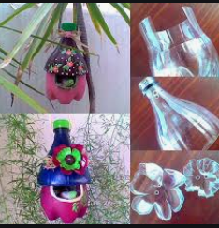
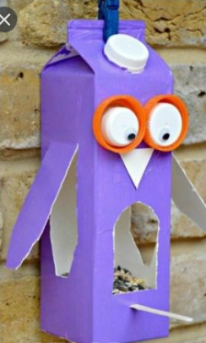

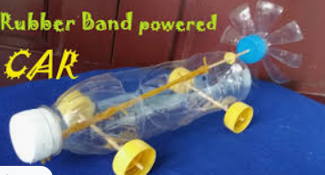
https://www.youtube.com/watch?v=k8AIq8w7zBE

